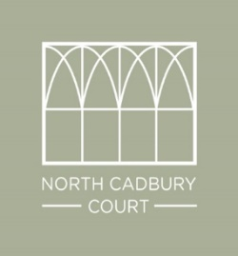

Local Places to Eat and Pubs

The Catash Inn – North Cadbury – very local, old-fashioned pub.

Teals – South Cadbury, breakfast, lunch and food market in walking distance
https://teals.co.uk

The Queens Arms – Corton Denham 3.5 miles from North Cadbury Court
Tel: 01963 220317 relax@thequeensarms.com www.thequeensarms.com

The George Hotel – Castle Cary
3.6 miles from North Cadbury Court
Tel: 01963 350761 enquiries@thegeorgehotelcastlecary.co.uk www.thegeorgehotelcastlecary.co.uk

The Kings Arms – Charlton Horethorne
4.4 miles from North Cadbury Court
Tel: 01963 220 281 admin@thekingsarms.co.uk www.thekingsarms.co.uk

At The Chapel – Bruton (pizzas and food, not a pub)
7.1 miles from North Cadbury Court
Tel 01749 814 070 mail@atthechapel.co.uk http://atthechapel.co.uk

Roth Bar and Grill – Bruton (part of Hauser and Wirth gallery)
7.3 miles from North Cadbury Court
Tel: +44 1749 81 4060 mail@rothbarandgrill.co.uk http://www.hauserwirthsomerset.com/roth-bar-grill

Red Lion, Babcary Beautiful thatched country pub
7.3 miles from North Cadbury Court
Tel: 01458 223230 info@redlionbabcary.co.uk www.redlionbabcary.co.uk

