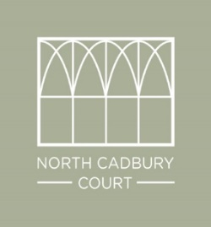

Croupier for North Cadbury Court Casino
Matt Isaacs 07810 012559 croupieratncc@yahoo.com

The casino has two rooms, one room containing Blackjack and Roulette, the other room containing Texas Hold'em poker.
Matt can deal Roulette and Blackjack and has colleagues who can deal Roulette, Blackjack and Poker, so it would be your choice as to which games you would like to be open. At any one time, approximately 8 people can play roulette, 7 can play Blackjack and 8-10 can play Texas Hold Em, but there is space for others to watch.
The casino is all for fun, rather than real money changing hands, so your guests are given 'fun money' to play with (we recommend notes in denominations of £200 and allow a total £400 per guest to play with). You will need prizes for your winning guests as you wish, we will collate the winning totals for you at the end of the evening.
The fee is £120 per croupier, paid direct to each croupier, which includes travel and up to 3 hours' continuous dealing.

I feel dreadful I never said farewell or a huge thank you to you last Fri night. I cannot tell you what a success the casino was - all the guests absolutely loved the gambling, it was a great hit. You both managed it brilliantly, I have had so many friends telling me how superb you both were at making it so approachable and enjoyable for everyone to join in, I don't know how you do it.
Thank you so so much for all you did and working so late for us. I really hope to see you soon and work with you at NC Court again soon
With huge thanks, Victoria
OFFICE: 01963 31937
MOBILE: 07976 815015
EMAIL: info@blashford-snell.co.uk
WEB: www.blashford-snell.co.uk

