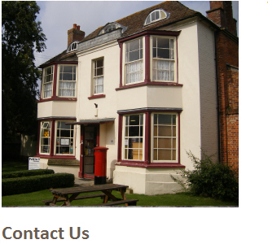
The Village Stores
6 Woolston Road, North Cadbury, YEOVIL, Somerset, BA22 7DW
Tel: 01963 440201
Email: village.stores@yahoo.com
Website: www.montgomerycheese.co.uk

Hello, our names are Bob and Jackie New and we run a small business based in North Cadbury, we are the retail arm of the world famous Montgomery cheese making family, who not only produce the well-known Montgomery's Cheddar, but also a new Jersey milk cheese Ogleshield.

OPEN 7 DAYS A WEEK
MONDAY 8 - 5.30
TUESDAY 8 - 5.30
WEDNESDAY 8 – 5.30
THURSDAY 8 - 5.30
FRIDAY 8 - 5.30
SATURDAY 8 – 1.00
SUNDAY 9 – 1.00

Our proximity to The Court is 100m which makes it accessible and convenient for us to help make your stay hassle free when it comes to arranging food supply whether it’s for a weekend or a week, for a family of four or a group of forty we can supply a whole range of products from the everyday essentials to a full roast dinner. Our ethos is to bring top quality local produce to your door in the most direct way possible. We think it is important that you need to know where your food comes from, and who produced it, we give preference to food produced in Somerset and believe in fair trade.

All items can be ordered on the Tuesday ready for delivery free of charge on the morning of your arrival (Thursday or Friday) so you can start enjoying yourselves as soon as you arrive, or if it’s just a cheese board for your event or maybe fresh warm croissants for the morning, whatever the occasion we can arrange delivery or collection.
We also have a web site where you can order any of the cheeses and we will send to your required destination. There is always a friendly and helpful voice at the end of the phone, should you need to contact us.

Remember we can also take orders over the phone, should technology fail!

Fresh Meat from Andrew Barclay of Wincanton
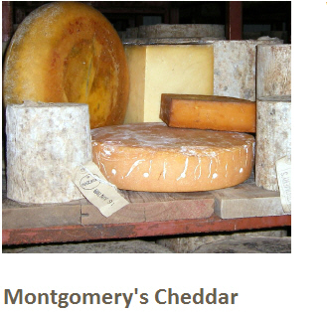
- Beef
- Lamb, Mutton and Goat
- Pork
- Gammon, Bacon & Burgers
- Sausages & Sausage Meat
- Poultry
- Game
Fish

World famous Montgomery Cheddar,and Ogleshield, produced next door, and a selection of other local cheeses from Longmans Dairy of North Cadbury, and Crook and Churn Dairy who also deliver our Fresh Milk and Cream

- Milk & Cream
- Butter and Cheese
- Yoghurt

Fresh Fruit and Vegetables delivered daily by Georges of Castle Cary
- Vegetables & Herbs
- Fruit

Bread, Rolls, Croissants, Danish pastries and Savouries baked fresh every day in Store.
The not to be missed Border Biscuits & Fudges Biscuits for cheese, free range eggs collected from nearby farms

- Bread and pastries
- Cakes & Biscuits
- Pies & Quiches
- Pasties & Savouries
- Eggs, Flour, Sugar, Yeast & Salt

Croissants £0.79
Pain au Choc £1.25
Pain au Raisin £1.25
Vanilla Crown £1.20
Apricot Crown £1.20
Apple Crown £1.20
Cinnamon Swirl £1.25
Maple Pecan £1.20
Organic Brown £2.25
Organic White £2.25
Tiger Bloomer £1.95
Malted Grain Cob £2.00

And not forgetting the Everyday Essentials
- Cereals
- Preserves and Spreads
- Crisps and Olives
- Sauces, Gravies, Jellies and Mustards
- Chutneys, Pickles & Pickled Products
- Dressings & Mayonnaise
- Ready Meals
- Desserts & Puddings
- Confectionery
- Culinary Oil
- Tinned Goods, Pulses & Seeds
- Drinks
- Tea, Coffee & Hot Chocolate
- Non Food
- Dog Food
- Cat Food
- Dry Cleaning
- Newspapers & Magazines
- Greeting cards & Stationary
- Off Licence

