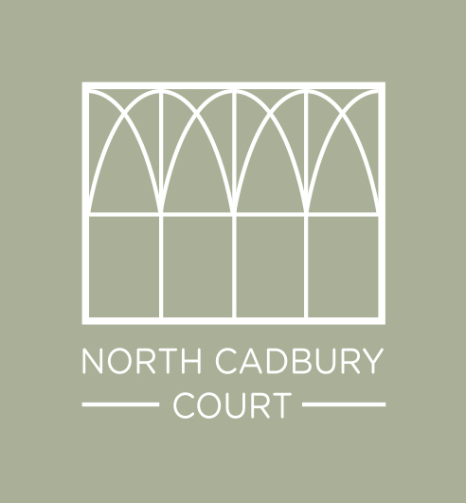
J, A & E Montgomery Ltd, Manor Farm, North Cadbury, BA22 7DW (reg England No: 00988752) trading as North Cadbury Court
The Premises: North Cadbury Court, North Cadbury, Yeovil, BA22 7DR

The Client:

The client agrees to the following whilst on The Premises:

Swimming Pool
Use of the swimming pool by us and our guests is at our own risk
The company and its owners are not liable for any loss or injury
No glass will be taken into the pool area
The pool will be locked during weddings and parties
We will inform our guests of the rules

Lake and outdoor games
Use of the Lake and equipment (pedalos/canoes/paddle boards etc), plus all outdoor games and equipment (bumper balls/golf buggy/bicycles etc) by us and our guests is at our own risk. The company and its owners are not liable for any loss or injury

Behaviour
Any behaviour during an event that could cause damage to the house or its reputation or disrespect to a member of staff will lead to the event being curtailed or stopped by North Cadbury Court staff or the owners

Allergies
North Cadbury Court and our staff cannot accept any responsibility for allergies and intolerances for yourself or your guests. Please make all reasonable attempts to establish any such requirements and pass this information to us. Please also bear in mind that food brought by you, your suppliers or your guests is not controlled by North Cadbury Court, therefore cross-contamination is not our responsibility.

Departure
The property will be left tidy with all items that have been used washed up and put away.
Bedrooms to be clear of dirty cups, glasses etc.
Rubbish and re-cycling taken outside to the re-cycling area
Any broken items reported to the House Manager on departure
All guests will be off-site by the agreed departure time
There will be a £100 charge for clearing vomit
There will be a £250 charge if smoking has taken place in the house

Dogs
Dogs will be kept on the ground floor only and not on furniture
We will clean up after our dogs. If extra cleaning is required or damage made by the dogs, the cost will be deducted from the damage deposit
Dog must not cause a nuisance to neighbours including excessive noise
Dogs will be kept under control and on a lead around livestock

Golf and tennis balls
A supply of used golf and tennis balls are available for your use. New balls can be purchased in the office with money placed in the honesty box or deducted from the damage deposit.

SIGNED:…………………………………………………………………DATE:……………………

